**Project name:**

FireLink

(File Sharing App)

System Analysis & Design

List of Content

Table of Contents

1. Chapter 1: 3

1.1 Overview. 3

1.2 Background (Project field). 3

1.3 Problem Statement (Definition). 3

1.4 Tools. 4

1.4.1. Software Requirements. 4

1.4.2. Hardware Requirements. 4

1.5 Benefits and Drawback. 4

2. Chapter 2: 5

2.1. History (Motivation). 5

2.2. Related Works. 6

2.2.1. Project Name + Project Icon. 6

2.3. Comparative Study. 10

3. Chapter 3: 11

3.1. What is the System? (Water fall, Agile, Scrum, etc…) 11

3.2. Functional and Non-functional Requirement Specification. 11

3.3. Proposed System (The Components of the System). 12

3.4. System Tools. 12

3.5. System Analysis. 13

3.5.1. UML Use-case Diagram. 13

3.5.2. UML Class Diagram. 14

3.5.3. UML Sequence Diagram. 15

3.5.4. UML Activity Diagram. 19

# Chapter 1:

## Overview.

A file hosting service, cloud storage service, online file storage provider, or cyber locker is an internet hosting service specifically designed to host user files. It allows users to upload files that could be accessed over the internet after a user name and password or other authentication is provided

Online file storage software applications allows a user to share his/her files 57. with other people. By using cloud computing, this service provides an interface between user and cloud to upload / download files, a quick file access link (URL) to share with others, a simple user-interface (UI) design to view files and their data, high-level security and smart user-friendly features.

## Background (Project field).

Online file storage services have become a very popular part of a field of study which is known nowadays as Cloud Computing.

In general, Cloud Computing is on-demand availability of computer system resources, especially data storage and computing power, without direct active management by the user. By using web applications, we can manage the process of uploading / downloading files through the cloud and allow users to share these files (keeping privacy & security) for general purposes.

..

## Problem Statement (Definition).

People around the world are used to send & receive files using hardware devices such USB, CD\DVD, etc.., but that method is consuming time that we can spend doing some useful stuff, here comes the role of the Internet and Cloud Computing to help us to solve this problem. Nowadays we can use Internet technologies to do operations on files easily and quickly, such 'CRUD' (Create, Read, Update, Delete) and share those files with our friends and many useful operations, only by having our files uploaded to the Cloud.

## Tools.

### Software Requirements.

* Modern Browser (Google Chrome, Firefox, etc ..)
* Internet Markup languages (HTML, CSS, etc ..)
* Integrated Development Environment (IDE)
* Scripting languages (JavaScript, PHP, etc ..)
* Programming language (Java, Kotlin, etc ..)
* Web development tools
* Test cases
* DBMS (Database Management System)

### Hardware Requirements.

* PaaS (Platform as a Service)

## Benefits and Drawback.

+ Ransom ware / Malware Protection.

+ Access Your Files Anywhere, Anytime.

+ Online File Management is Affordable.

+ Upload larger files using file hosting system.

+ Recovery of Lost Files.

+ Reduces Costs & saving time

* Backups May Be Slower.
* Higher Internet Utilization.
* Bandwidth limitations.
* Vulnerability to Attacks.
* Duplication of data.
* Potentially breaking copyright laws.

# Chapter 2:

## History (Motivation).

The first software application that served online file hosting known as Windows Live Folders at the time (with a codename of SkyDrive), was provided as a limited beta available to a few testers in the United States. On August 1, 2007, the service was expanded to a wider audience. Shortly thereafter, on August 9, 2007, the service was renamed Windows Live SkyDrive and made available to testers in the United Kingdom and India. As of 22 May 2008 SkyDrive was initially available in 38 countries and regions. later expanded to 62. On December 2, 2008, the capacity of an individual SkyDrive account was upgraded from 5 GB to 25 GB, and Microsoft added a separate entry point called Windows Live Photos which allowed users to access their photos and videos stored on SkyDrive. This entry point allowed users to add "People tags" to their photos, download photos into Windows Photo Gallery or as a ZIP file, as well as viewing if metadata such as camera information for the photos uploaded. Microsoft also added the ability to have full-screen slide shows for photos using Silverlight.

On August 14, 2012, Microsoft announced a new update for SkyDrive which brought changes and improvements to SkyDrive.com, SkyDrive for Windows desktop and OS X, and the SkyDrive API as part of Live Connect. For SkyDrive.com, the updates brought a new "modern" design for the web service consistent with Outlook.com, and along with the UI update the service also received improvements such as instant search, contextual toolbar, multi-select in thumbnail view, drag-and-drop files into folders, and sorting improvements. For the SkyDrive for Windows desktop and macOS applications, the update brought new performance improvements to photo uploads and the sync experience.

## Related Works.

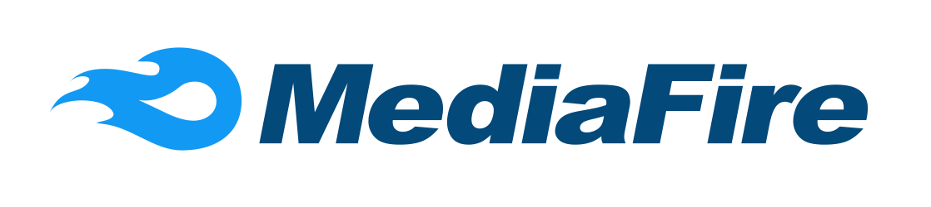

### MediaFire

#### Overview.

**MediaFire** is a simple to use free service that lets you put all your photos, documents, music, and video in a single place so you can access them anywhere. It’s one of the largest cloud storage and file sharing platforms on the Internet.

#### Methodology.

*The service is available for free and allows users to upload files of up to 200 MB. The user is then supplied with a unique URL, which locates the file and enables anyone with whom the uploader shares it to download the file. Currently there is no time limit on how long uploaded files will be stored. Furthermore, images can be uploaded and displayed in galleries.*

#### Advantages.

* + - SSL upload encryption available.
    - Easily share large files and folders.
    - Instantly recover deleted files.
    - Share and collaborate on files with friends
    - Sync files selectively to your desktop from the cloud.

#### Disadvantages

* + - Very small file size limits for free accounts.
    - Slow upload rate, often around a 200KBPS
    - You cannot password protect folders
    - Free accounts DO NOT offer long term storage
    - No FTP upload

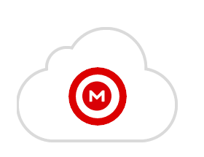

### Mega

#### Overview.

*MEGA is a secure cloud storage service with 50 GB free storage space. This version contains the new download page video viewer, MEGAdrop public upload folder feature, file versioning and MEGAchat (with video, audio and text chat capability). This extension will allow you to install MEGA into your browser. Mega is currently used by approximately 150 million people*

#### Methodology.

*Files and folders stored to MEGA can also be shared with others. Sharing is accomplished through the generation of links. There’s no option to email access with MEGA, so you’re left to handle the distribution process on your own.*

*MEGA does have some nice options to bolster the security of your link sharing, though. For example, rather than limit you to creating a basic link that anybody can use to access, MEGA gives you two options:*

***Link without key****: generate a URL link and decryption key that can be shared separately*

***Link with key****: generate a URL link with the decryption key embedded in it*

#### Advantages.

* + - Apps for all platforms and browser extensions.
    - Web client for access from any browser.
    - Share files with contacts in a fully encrypted state.
    - Create encrypted and password protected links to your files.
    - Preview photos and videos on the fly.

#### Disadvantages

* + - The encryption key is shared in the link which could compromise the security.
    - Does not implement incremental file transfers into its sync architecture.
    - Security structure doesn't give users the two-factor authentication.
    - No dedicated desktop client.

### 

### DropBox

#### Overview.

*Dropbox is a file hosting service operated by the American company Dropbox, Inc., headquartered in San Francisco, California, that offers cloud storage, file synchronization, personal cloud, and client software. Dropbox was founded in 2007 and it has been ranked as one of the most valuable startups in the US and the world, with a valuation of over 10 billion dollars.*

#### Methodology.

Dropbox brings files together in one central place by creating a special folder on the user's computer. The contents of these folders are synchronized to Dropbox's servers and to other computers and devices where the user has installed Dropbox, keeping the same files up-to-date on all devices. Dropbox uses a freemium business model, where users are offered a free account with a set storage size, with paid subscriptions available that offer more capacity and additional features. Dropbox Basic users are given two gigabytes of free storage space.

#### Advantages.

* + - Automating tasks
    - Convert pdf files.
    - Create a slideshow
    - Resize images
    - Send files to other services
    - IFTTT support
    - Integration with Kindle formats
    - Save the saccharin shot

#### Disadvantages

* + - Dropbox does not have to give you 24 hours to whistle the bandwidth.
    - Dropbox closes traffic when the allowed bandwidth is exceeded .
    - Allows 20 minutes per day are provided for free accounts and only 200 minutes for paid accounts.
    - Links are automatically blocked if they generate unusually large amounts of traffic

### 

### OneDrive

#### Overview.

*Microsoft OneDrive is a file hosting service and synchronization service operated by Microsoft as part of its web version of Office. First launched in August 2007, OneDrive allows users to store files and personal data like Windows settings or BitLocker recovery keys in the cloud, share files, and sync files across Android, Windows Phone, and iOS mobile devices, Windows and macOS computers, and the Xbox 360 and Xbox One consoles. Users can upload Microsoft Office documents directly to OneDrive.*

#### Methodology.

Microsoft added Office for the web (known at the time as Office Web Apps and later Office Online) capability to OneDrive in its "Wave 4" update, allowing users to upload, create, edit and share Word, Excel, PowerPoint and OneNote documents directly within a web browser. In addition, Office for the web allows multiple users to simultaneously co-author Excel documents in a web browser, and co-author OneNote documents with another web user or the desktop application. Users can also view the version history of Office documents stored on OneDrive.

#### Advantages.

* + - 15GB free storage for each user
    - OneDrive and Office 365 work together together
    - OneDrive service is not limited to Windows 10.
    - Enabling the Groove Music Streaming application
    - All you need is an account on the Microsoft Corporation website

#### Disadvantages

* + - If you are one of the people who has difficult access to the Internet, it is not practical for you to serve.
    - Until now, this service is not completely practical, as it does not have features such as those provided by the personal device until it can be overridden.
    - From the security point of view, if you are subscribed to a company that distributes the service and it is compromised, your data will be at risk.
    - Browsing and using this service in general is related to the speed of the internet, so if you are a country that provides a weak internet, you will not be able to use this service well.

## Comparative Study.

|  |  |  |  |  |  |
| --- | --- | --- | --- | --- | --- |
| NAME | OVERVIEW | METHODOLOGY | BENEFITS | DRAWBACKS | RATE |
| Media-Fire | MediaFire is a file hosting, file synchronization, and cloud storage service | User is then supplied with a unique URL, which locates the file and enables anyone to download the file | Easily share large files and folders. | Slow upload rate, often around a 200KBPS | 9/10 |
| Mega | MEGA is a secure cloud storage service with 50 GB free storage space. | Mega has all platform applications, you can search, upload, download, stream, and share any of your files on the go. | Share files with contacts in a fully encrypted state. | 1. No link download limits 2. Speed can vary | 7/10 |
| DropBox | file hosting service operated by the American company Dropbox | brings files together in one central place by creating a special folder on the user's computer | Integration with Kindle formats | Closes traffic when the allowed bandwidth is exceeded | 8/10 |
| OneDrive | file hosting service and synchronization service operated by Microsoft | Office for the web (known at the time as Office Web Apps and later Office Online) | OneDrive and Office 365 work together together | Browsing and using this service in general is related to the speed of the internet | 8/10 |

# Chapter 3:

## What is the System? (Water fall, Agile, Scrum, etc…).

The appropriate methodology to develop FireLink application is Agile method, since the requirements are clear and deterministic, even can be predicted. Agile method's motto is (Design for change) which means that Agile method fits in perfectly to this type of software, since a lot of new features come to mind along with design & implementation phases, and Agile accepts changes by interleaving design, implementation and testing phases for fast high-quality software development.

## Functional and Non-functional Requirement Specification.

3.2.1 Functional Requirements:

* Allow any user to upload a file
* Pre-determined file types
* Files & URLs are deleted after a specific time
* Allow anonymous file upload
* Encrypt files names in both servers and database
* Provide an option for reporting files
* Each file has a secure code, used later for authenticated file deletion.
* User can contact owners
* Store [Id | type | name | size | extension | upload hour | keep for | username | secure code | created at] for each file in database.

3.2.2 Non-functional Requirements:

* Enable enough bandwidth
* Enable large file sizes for uploading
* Use HTTPS & SSL ports for secure connection
* Enhance search, sort and SQL queries in general.
* Ensure privacy of information.

## Proposed System (The Components of the System).

FireLink is a software application for file hosting & sharing management which aims to make the process of sharing files between people much easier than ever known. FireLink **allows any user to upload** his/her **files without the need for registration & login , fully free and no Ads**. The system **accepts many file types to be uploaded & hosted.** It involves **file attributes encryption & decryption** for secure software components communication. **Auto file deletion** is involved; **user can determine the amount of time to keep the file alive**. A **secure code (password) is shown only to the user who uploaded the file**, it's used to delete the file later.

## System Tools.

**Computer Languages**:

HTML, CSS, JavaScript, C#, SQL

**Frameworks**:

ASP.NET | SASS | Bootstrap | FontAwesome | Webpack

**Tools:**

GIT | Terminal | DBMS (cPanel) | Test cases

**Interpreter / IDEs:**

Browser (Google Chrome) | Visual Studio | Atom

## System Analysis.

### 

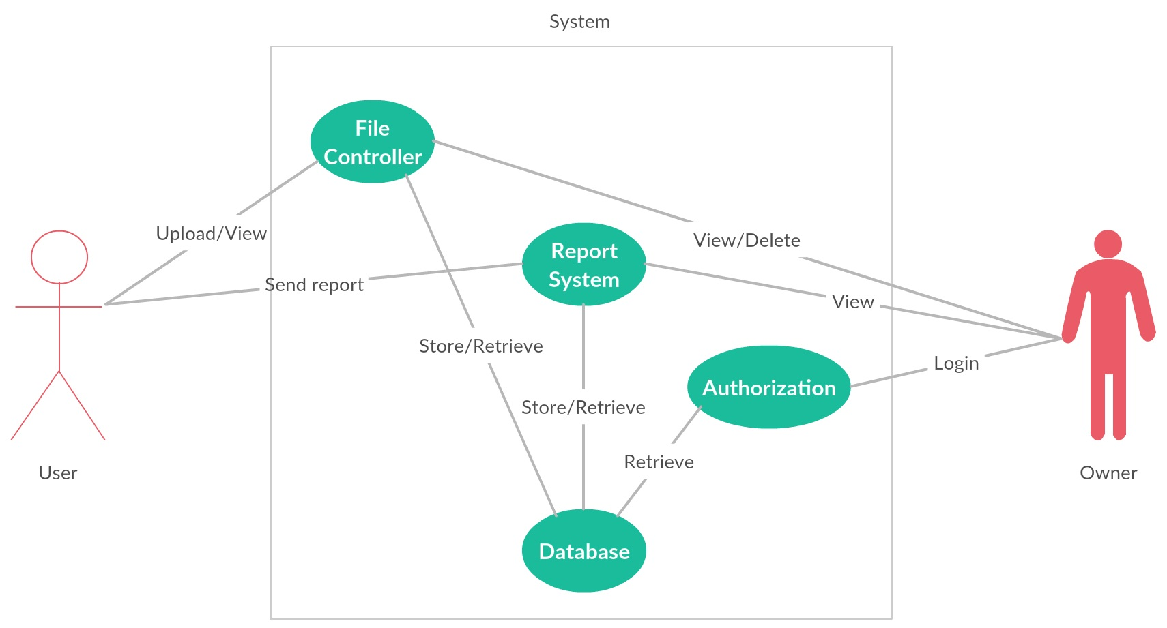

### UML Use-case Diagram.

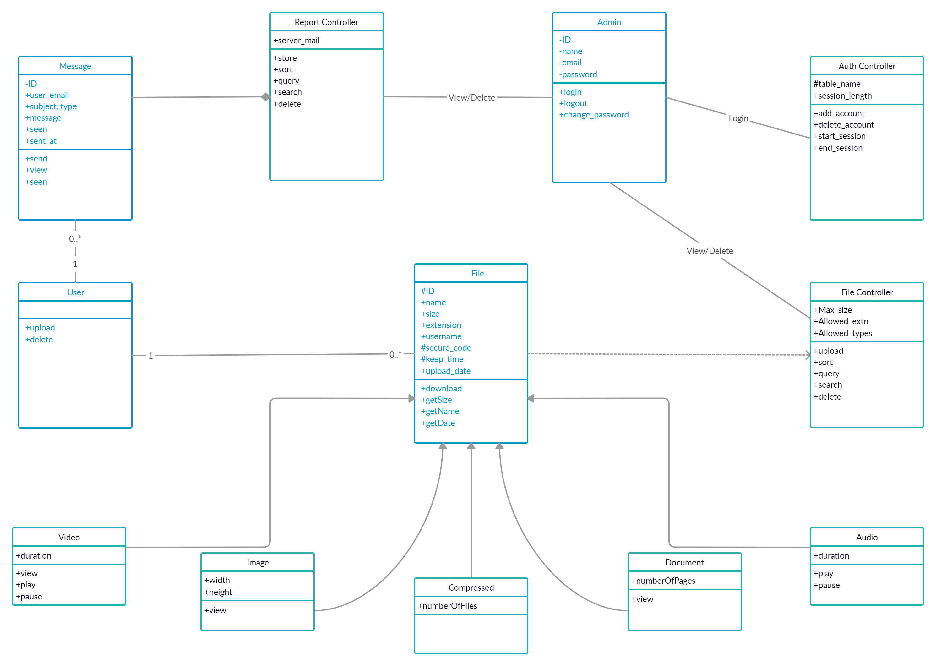

### UML Class Diagram.

### UML Sequence Diagram.

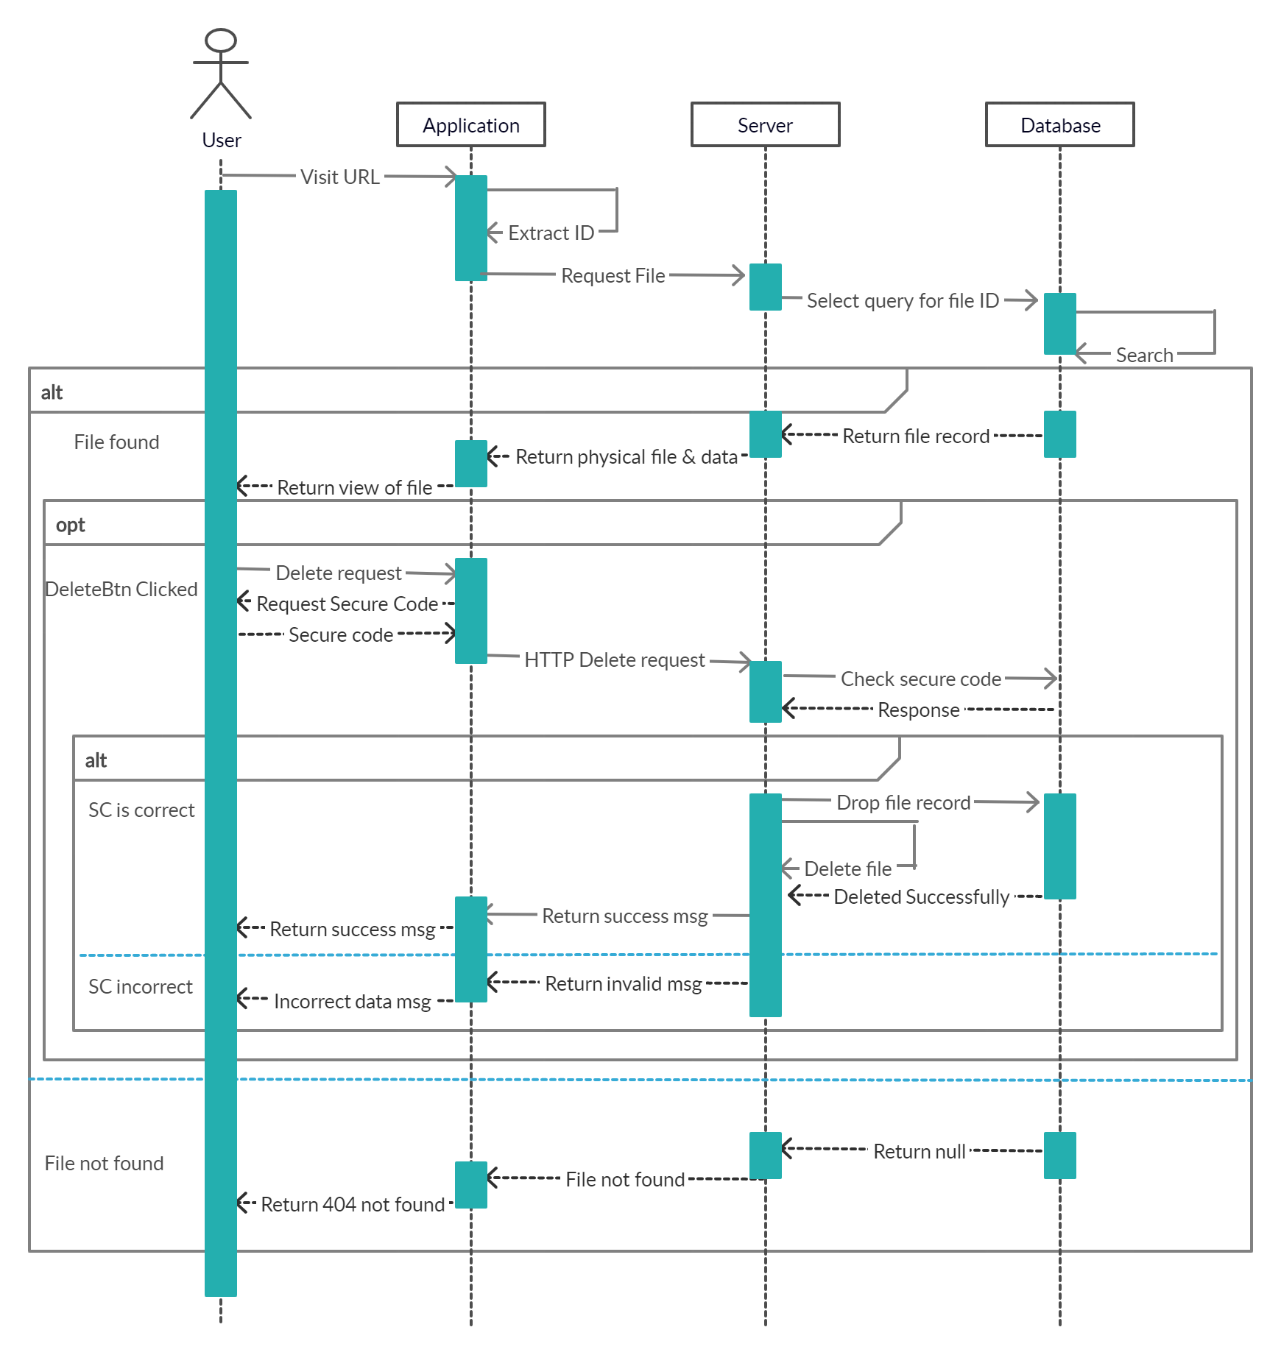

**Figure 1.1 sequence diagram for actions on file**

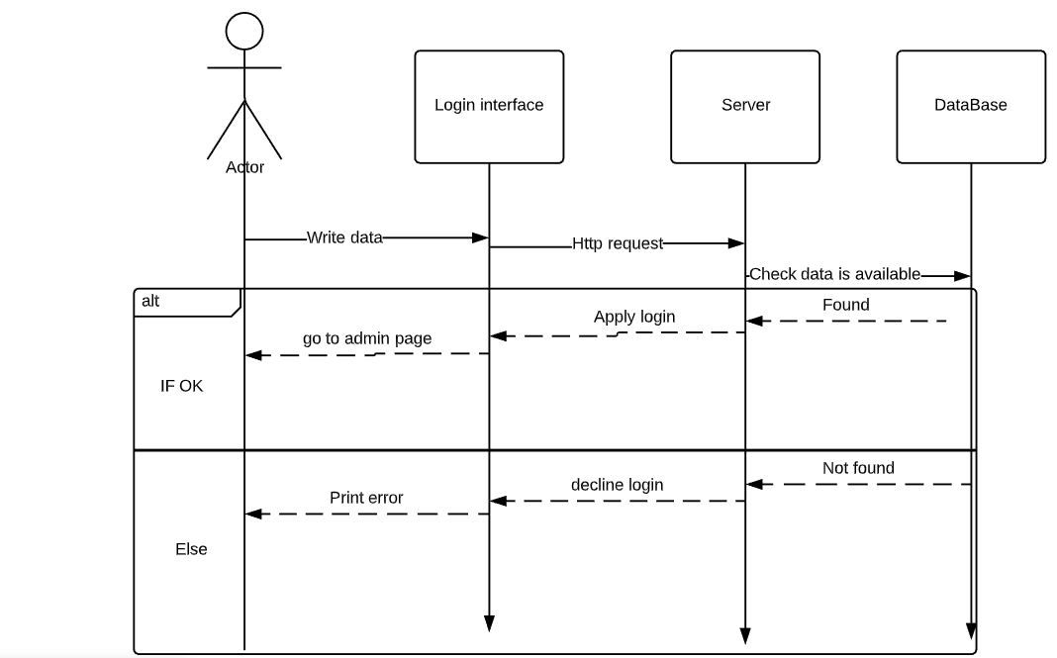

**Figure 1.2 sequence diagram for admin authentication**

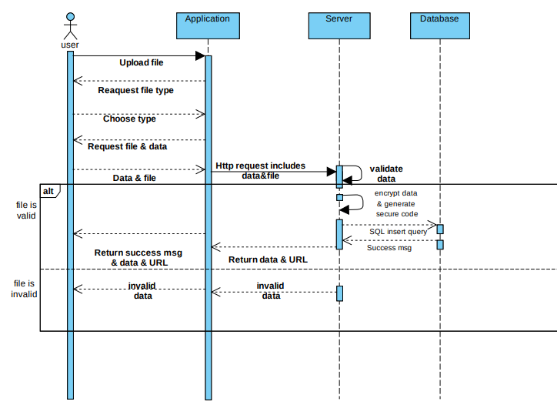

**Figure 1.3 sequence diagram for uploading a file**

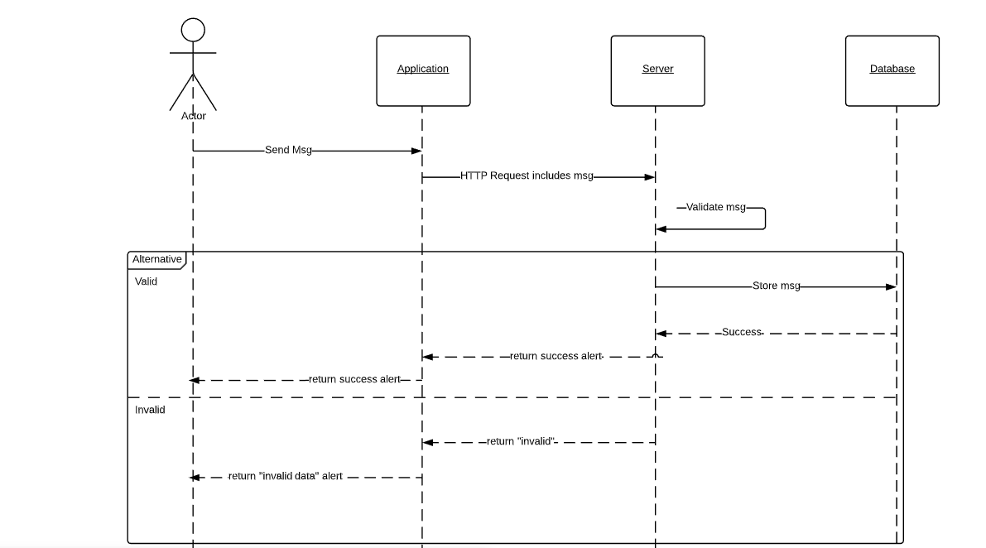

**Figure 1.4 sequence diagram for sending message (report)**

### UML Activity Diagram.

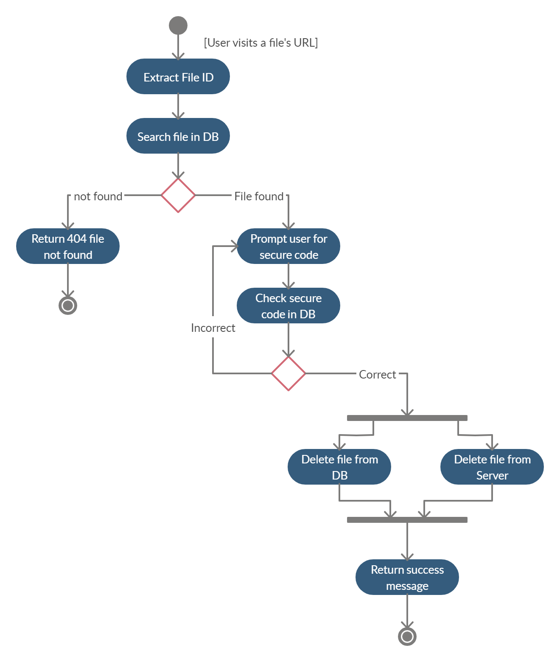

**Figure 2.1 Activity Diagram for operations on file**

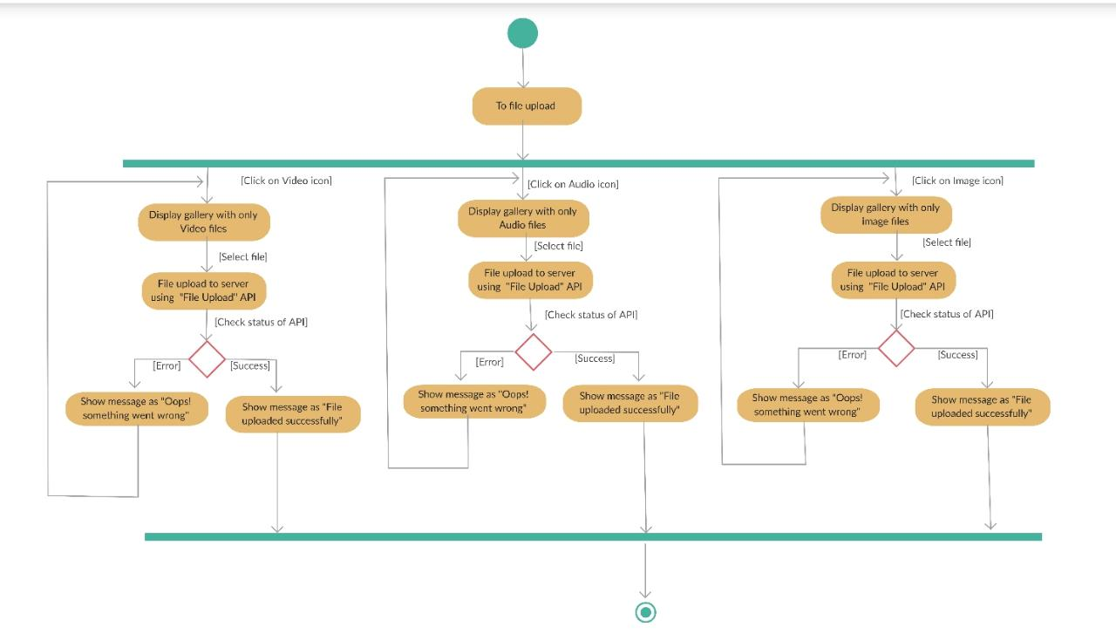

**Figure 2.2 Activity Diagram for uploading file**

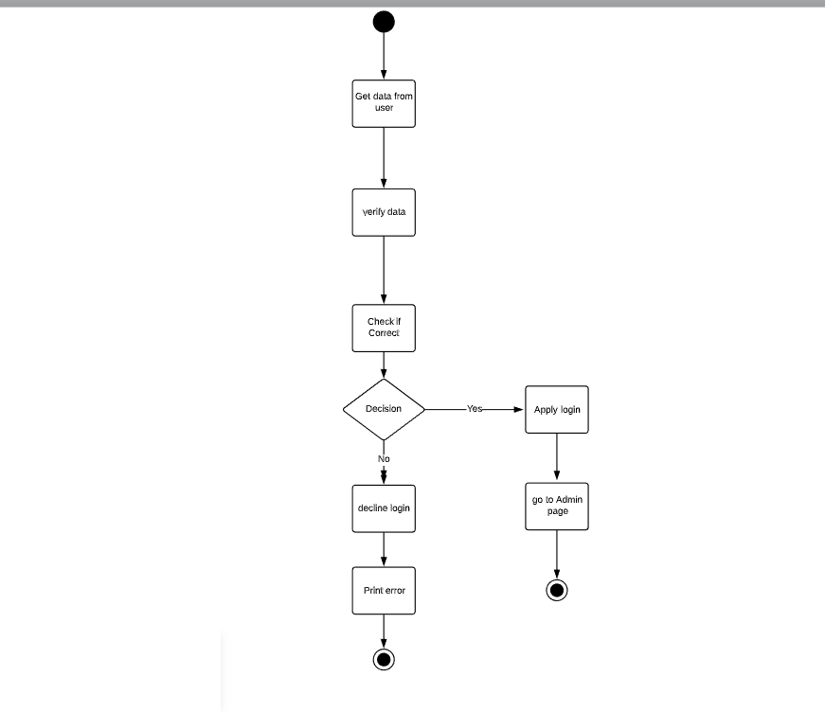

**Figure 2.3 Activity Diagram for authentication**

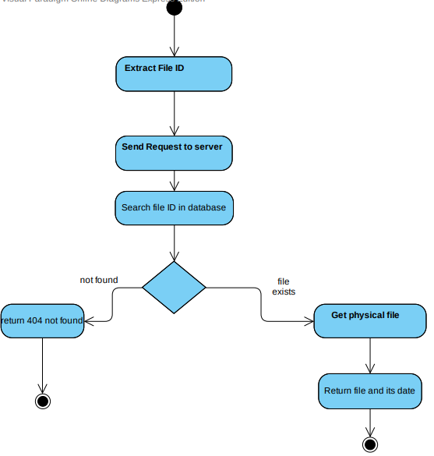

**Figure 2.4 Activity Diagram for accessing a file**